International Marketing

TGC COFFEE to

Sweden

Group: DIM
S1163010 Ann
S1163021 Grace
S1163017 Charlene
S1163048 Liyu
S1163050 Celeste

Table of Contents

Introduction of TGC 1

The Target Segment 1
Geographical segmentation 1
Demographic segmentation 1
Psychological segmentation 2

Segmentation Needs 2

Pricing 3

Promotion 3

Positioning 4

Product 5~6

3Ps 6
People 6
Process 7~8
Physical Evidence 8
Conclusion 8

Introduction of TGC
TGC (Taiwan Good Coffee) was established in Yulin Gukeng in 2004. It launched coffee planted by Gukeng local smallholders and drip-bag coffee, purchasing pesticide-free coffee at a reasonable price. TGC started to break into international markets in 2011, with the best of the bunch, delivering a warm Taiwanese coffee to the world.

The Target Segment

Geographical segmentation

Density
About 90% of Sweden's population is located in the central and southern parts of the country, and Stockholm, Gothenburg and Malstock are the top three populated cities in Sweden.

Demographic segmentation

Races
The ethnic distribution in Sweden is as follows: Swedish 80.3%, Syrian 1.9%, Iraqi 1.4%, Finnish 1.4%, other 15% (2020 est. by the CIA).

Income
According to income statistics in Sweden in 2022 (based on income class), 31% of the population aged 20-64 have an annual income between 300,000 and 450,000 Swedish kronor (i.e. a monthly income of approximately 25,000 to 38,000 kronor).

Education
In Sweden, 23% of 25-34 year-olds have a VET(vocational education training) qualification as their highest level of attainment : 17% at upper secondary level, 2% at post-secondary non-tertiary level, and 4% at short-cycle tertiary level.

Psychological segmentation

Life Style
Fika custom and Lagom philosophy are two well-known cultural representatives in Sweden.
In Fika, people drink coffee, have desserts and chat without time limits in their busy schedules. The concept is not the same as afternoon tea, it’s to allow people to enjoy communication and gathering with each other at all times. fika also has an impact on improving efficiency. A sense of ritual recharges people’s bodies and minds.
Lagom is a daily philosophy of life, focusing on a just-right or balanced attitude in life. This lifestyle not only exists in interpersonal interactions, but is also applied to work. In addition, Sweden is the country that enjoys loneliness the most in the world. Swedes enjoy single life and believe that being alone is a display of beauty and power. They don't care much about love or marriage. Neither do they take the initiative to contact strangers or neighbors. In addition, sambo is a unique marriage status in Sweden (cohabitation but with no marriage), and the divorce rate in Sweden is nearly 44%.

Segmentation needs
In summary, we identify these market segments mainly by considering the needs of local consumers. Sweden has Fika culture, and this custom gives Swedes opportunities to drink coffee, and Lagom satisfies their leisure time needs. To sum up, our marketing targets are based on two points: areas with large population distributions and the highest proportion of ethnic groups. And the target customer group is mainly those with certain economic ability(middle class), such as households and office workers.

Pricing
To determine our product price, we chose cost-plus method, which adds up all the costs and expected profit to set a price.
According to online information, importing goods from countries outside the EU, the general food (except for alcohol and cigarettes) VAT rate in Sweden is 12%. Adding the cost of coffee in Taiwan, freight forwarder,and our expected profit. there will be our target price.

Promotion
There are three strategies to promote our product.

Online websites
The customer service of the official website shall be patient and professional. Also, it’s important to reply to any questions and problems as quickly as possible.

Brick and mortar store
The clerks shall be nice and give customers private rooms. Moreover, keeping a cat or a dog in the store would bring natural and harmonious vibes to make customers feel free and comfortable.

Hypermarket
Corporate with hypermarkets to give some samples as customers reach the figured amount.

Positioning
Our product is TGC drip bag coffee, which is positioned as a premium, convenient coffee solution suitable for Swedish Fika and Lagom lifestyles. Our products offer high-quality flavor in an easy-to-use format. The design of the drip bag specializes in quick and effortless preparation, making it ideal for those who need coffee during their busy day. Simply place the drip bag coffee over the cup, pour hot water, and within minutes, there would be a cup of delicious coffee without the need of any special equipment or technical skill. The taste of TGC coffee is not too strong, with a fruity sweetness after the bitter flavor fades.
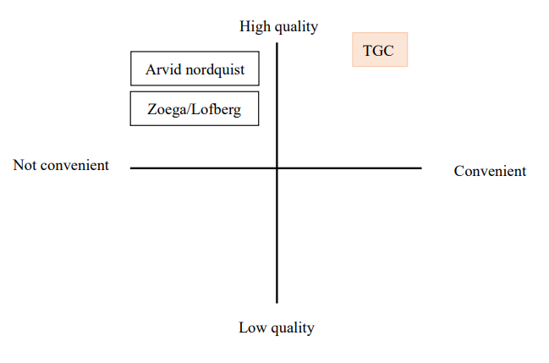
Figure 1 Positioning map
Figure1 is our positioning map, comparing to three other Swedish brands, TGC coffee can take into account convenience and high quality. TGC coffee uses an intelligent system, such as field monitoring and agricultural production record, agricultural product processing record system to detect and ensure the quality of coffee beans.In Figure1, other Swedish brands have their own product characteristics. However, local coffee brands in Sweden rarely have drip bag coffee, and most of them are in the form of coffee beans.
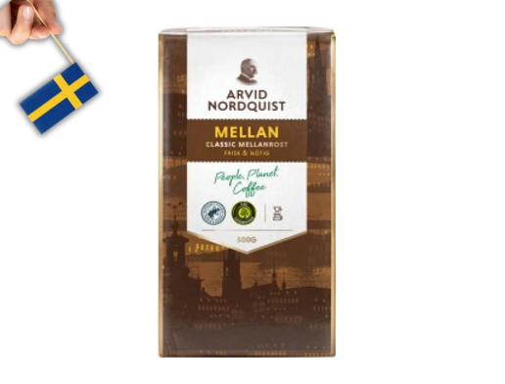
Figure 2 ARIVD NORDQUIST
ARIVID NORDQUIST is known for using high-quality Arabica coffee beans,which are grown by certified farmers, and ensuring consistent quality and taste in every batch. Also they work actively to reduce the emissions and impact on the environment, they compensate for the carbon emissions they haven’t yet managed to tackle through tree-planting schemes in coffee-growing countries.
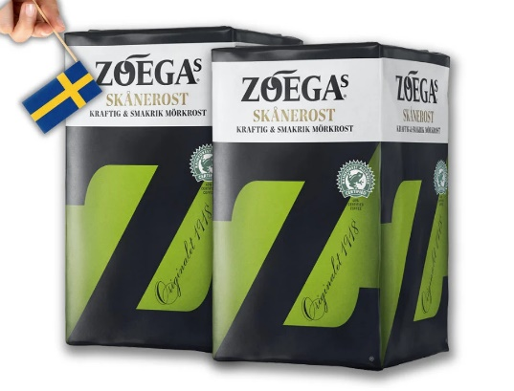
Figure 3 ZOEGA
ZOEGA’s main markets are Sweden and Scandinavia, where product development is tailored to local consumer tastes and preferences. It’s famous for dark roast coffee. It’s worth mentioning that ZOEGA launched Coffee for Women, a sustainable coffee program in Kenya, Rwanda, and Uganda to make coffee production more profitable and inclusive.
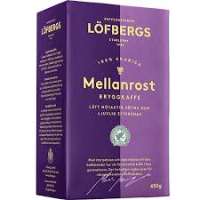
Figure 4 Löfbergs
Löfbergs founded in 1996, it’s one of Sweden’s oldest coffee brands, known for its traditional coffee-making techniques and high-quality products. Their products are environmentally friendly and sustainable and hold several organic certifications. The brand is committed to reducing its carbon footprint and supporting organic and sustainable coffee farming.

Product
Swedish has a special lifestyle called fika, which means the time with coffee and snacks. It represents a huge part of Swedish culture and a work-life balance.For Swedish, Fika can bring people closer and build connections between each other. Also, it takes less effort to prepare and can be completed within an hour. It is neither too long nor too short, suitable for Swedish people who value everything just right.
Our product, TGC drip bag coffee comes in individually packaged drip bags. Each bag contains freshly ground coffee, sourced from Taiwan’s best coffee farms, embodying the essence of fika. Designed with convenience and quality, TGC drip bag coffee is able to incorporate the Swedish lifestyle, whether during a busy workday or a relaxing afternoon. Quality is the heart of TGC drip bag coffee, our products source high-quality coffee beans and roast them to reach perfection to highlight the natural flavor. The taste is balanced, not too overpowering, with an initial bitterness that transitions smoothly to fruity sweetness. Healthy is also a key aspect of our products, we contract with coffee farmers across Taiwan to purchase safe and pesticide-free coffee beans at reasonable prices, and regularly send the coffee beans to perform the SGS inspection center every year to pesticide residue, heavy metal residue, and mycotoxin testing to ensure the safety of coffee products.

3Ps

People

Production Staff
The production team comprises personnel for planting, roasting, and packaging. These personnel must possess specialized skills and competencies to ensure both cultivated coffee beans and resulting coffee powder meet high quality standards. It is essential for producing premium drip coffee and fulfilling the material needs of our customers.

Sales Staff
Sales personnel play crucial roles as customers’ first point of contact, necessitating a positive service attitude to ensure excellent customer experiences. This leads to increasing customers’ willingness to consume and enhances customer loyalty. For online sales personnel, it is essential to ensure a friendly and patient attitude with professional responses when addressing public inquiries. Offline sales personnel should maintain a friendly, proactive attitude without being overly enthusiastic. Given the reserved and independent nature of Swedish people, excessive enthusiasm may lead to adverse reactions. During the sales process, it is advisable to suggest our products directly and concisely, focusing on understanding the customers’ needs rather than merely highlighting the product’s advantages.

Process

Logistics
Offering fast delivery services can enhance customers’ shopping experience, increasing their trust and satisfaction with the brand. Conversely, slow delivery and delays can diminish customer satisfaction and increase order cancellations. Therefore, partnering with local Swedish logistics companies to establish a small-scale warehousing system can facilitate order processing and improve shopping speed.

After-sales service
Providing comprehensive after-sales services helps to enhance customer satisfaction, deepen brand loyalty, and increase customer retention rates. Therefore, in addition to offering professional customer service, we believe it is beneficial to implement a robust return and exchange policy and include coffee brewing instructions in the product packaging. For example, instructions on the optimal amount of water to highlight the coffee’s flavor and quality. We can also include useful tips, such as dried coffee grounds for dehumidifying, deodorizing, and pest control. Increasing interactions with customers in this way makes them feel valued and cared for.

Official website
Putting information on the official website helps customers better understand our product. We can also put QRcode which links to our official website on the package, this can help customers easier to purchase again.

Membership program
For our company, membership programs can incentivize repeat purchases through points, discounts, and exclusive offers, thereby boosting customer loyalty. It also allows us to collect data on customer behavior and preferences, which can be used to improve products and services and develop more effective marketing strategies.
For customers, members enjoy exclusive discounts, point redemptions, and promotional activities, increasing the value of their purchases. They can also receive personalized recommendations and services based on their purchase history and preferences, improving their shopping experience.

Physical Evidence
Customers would like to try new brands if we provide free samples. They can try the product for free before purchasing, which reduces their risk and increases their trust. It also allows more potential customers to experience the product, increasing brand exposure. Also, participating in coffee markets attracts large numbers of potential customers, providing more opportunities for brand exposure, and face-to-face interaction with customers allows for better understanding of our products. Additionally, we can include a booklet introducing coffee knowledge inside the package to help customers better understand the features of our products and arouse customers' interest in collecting.

Conclusion
First of all, the advantages of TGC drip-bag coffee we sell are "natural and burden-free", "easy to carry", and "safety detection mechanism". Through STP analysis, we can better grasp the customer groups to choose and how to position our products more clearly. In addition, TGC coffee uses an intelligent system to control and ensure the quality of coffee beans, so that consumers can have a safe experience. Considering the classic Swedish FIKA culture, filtered coffee not only caters to the convenience sought by busy people, but also allows people to use this rest time more flexibly. Since Swedish coffee is mostly in the form of coffee beans, there is less filtered coffee, so I think this is also one of the keys for us to enter the market. In addition, direct communication with customers is something that needs special attention. For example, the positivity of online customer service replies and the speed of product delivery will affect consumers' willingness to buy. Therefore, building a strong online image, providing free samples, and participating in local coffee events are recommended strategies to build brand awareness and cultivate a loyal customer base. In general, TGC's entry into the Swedish market is a strategic opportunity to introduce Taiwanese coffee culture while meeting the needs of Swedish consumers' discerning tastes and lifestyles. By combining its products with local customs and preferences, TGC can establish itself as a leader in Sweden's highly competitive coffee industry.

Introduction of TGC. Retrieved from: https://twrr.org.tw/zh-TW/partner/16#:~:text=2004%E5%B9%B4%EF%BC%8C%E5%89%B5%E7%AB%8B%E4%BA%86%E9%9B%B2,%E7%84%A1%E8%BE%B2%E8%97%A5%E7%9A%84%E5%92%96%E5%95%A1%E8%B1%86%E3%80%82
Sweden. Retrieved from:https://zh.wikipedia.org/zh-tw/%E7%91%9E%E5%85%B8
Ethnic distribution of Sweden. Retrieved from: https://zh.oosga.com/demographics/swe/
Income and Tax Statistics. Retrieved from https://www.scb.se/en/finding-statistics/statistics-by-subject-area/
Income and Tax Statistics. Retrieved from:household-finances/income-and-income-distribution/income-and-tax-statistics/
Education at a Glance 2023: OECD Indicators. Retrieved from: https://www.oecd-ilibrary.org/sites/533a44bc-en/index.html?itemId=/content/component/533a44bc-en
Fika. Retrieved from: https://ai.glossika.com/zh-tw/blog/swedish-fika-culture-and-pastries
Life Style. Retrieved from: https://www.bbc.com/ukchina/trad/vert_cap/2016/01/160128_vert_cap_sweden-fika
Life Style. Retrieved from: https://www.cw.com.tw/article/5075382
Life Style. Retrieved from: https://buzzorange.com/vidaorange/2021/12/21/swedish-lagom/
Life Style. Retrieved from: https://onepercent.storm.mg/article/4527743
Life Style. Retrieved from:https://dq.yam.com/post/12424
Life Style. Retrieved from:https://visionproject.org.tw/story/6287
Shipping from China to Sweden. Retrieved from: https://dfhfreight.com/portfolio-item/china-to-sweden/#2
Retrieved from: https://www.wiadvance.com/cases-article/20200609/
Retrieved from: https://www.arvidnordquist.com/
Retrieved from: https://www.zoegas.se/
Retrieved from: https://www.lofbergs.co.uk/
Retrieved from: https://studyinsweden.se/blogs/2023/12/01/fika-culture-in-sweden-and-why-its-super-important/
Retrieved from: https://dq.yam.com/post/14847
Retrieved from: https://www.tgc-coffee.com/
Retrieved from: https://sunrisemedium.com/p/117/how-does-omnichannel-transform-consumer-behavior
Retrieved from: https://www.epochtimes.com/b5/13/11/5/n4003351.htm/amp
Retrieved from: https://a1.digiwin.com/essay/essay-content.php?detail=870
Retrieved from: https://wiki.mbalib.com/zh-tw/%E5%94%AE%E5%90%8E%E6%9C%8D%E5%8A%A1

